

Brno University of Technology

Faculty of Information Technology

Advanced Database Systems
2025/26

Rental Information System
Documentation

Eyobed Awel Nuri (xnuriey00)
San Kaung (xsankau00)
07/12/2025

Introduction
This application allows users to manage real estate inventory, visualize properties on an interactive map, and perform advanced searches using text, spatial location, and multimedia image analysis.

Usage

Login Screen
When you first launch the application, you'll see the login screen.

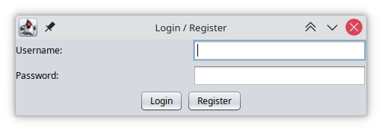
Admin: Full access including user management and critical database operations
Regular User: Can manage properties and others

Default Credentials:

Admin User:
Username: admin
Password: admin

Regular User:
Username: user1
Password: pass123

you can also register with a user and password of your own choice as a regular user

Main Interface Overview
The main window is divided into three sections:

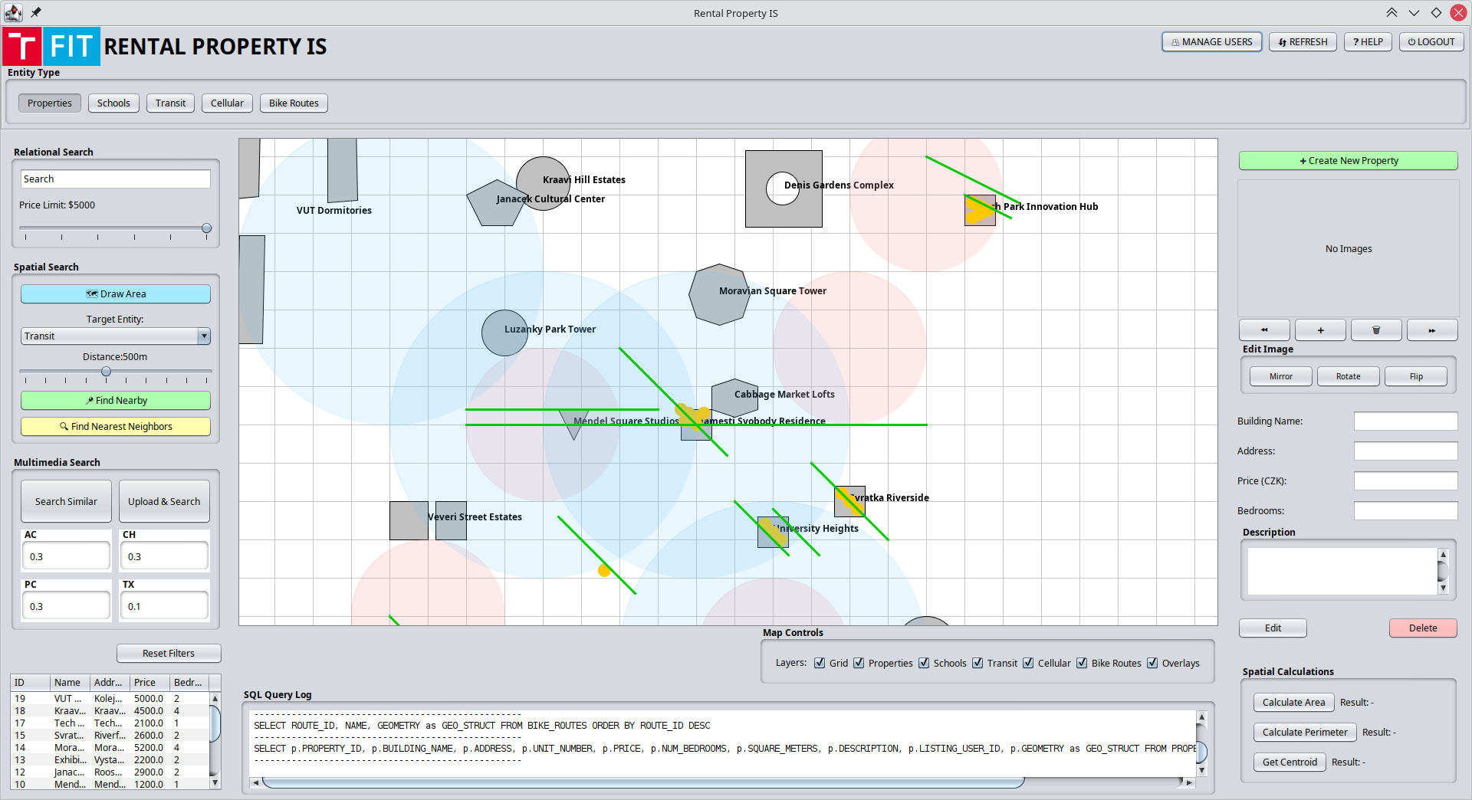
Top Menu Bar

Top Menu Bar (Right)
Manage Users : only appears if you are an administrator. Lets you manage users and DB
- Refresh: Reloads the application and resets the default settings.
- Help: Opens the help documentation window.
- Logout: Ends your session
.
Entity Type (Top Left)
Located below the main header, these buttons allow you to switch the active context and view specific data tables:
- Buttons: Properties, Schools, Transit, Cellular, Bike Routes.

Searching Methods (Left Panel)
Different kinds of search methods are located in left panel of the application.

Relational Search
- Search Bar: Type keywords (e.g., Building Name, Address) into the text box.
- Price Limit: Use the slider to set your maximum budget (e.g., $5000).

Spatial Search
Find properties based on geography and proximity to other entities.
- Draw Area: Click this blue button, then click on the map to define a search polygon (e.g., a specific neighborhood). Double-click to close the shape.
- Target Entity: Select the type of facility you want to search near (e.g., Transit, Schools) using the dropdown menu.
- Distance Slider: Adjust the slider to set the maximum radius (e.g., 500m).
- Execute Search:
  - Find Nearby (Green Button): Finds properties within the specified distance of the selected entity type.
  - Find Nearest Neighbors (Yellow Button): Finds the closest specific data points to your selected property. Could be a transit stop, a school or a bike path

Multimedia Search
Find properties that visually match a reference photo.
- Search Similar: Initiates a search based on currently selected criteria.
- Upload & Search: Upload a reference photo (e.g., a brick house) to find similar-looking properties in the database.
- Feature Weights (AC, CH, PC, TX): Prioritize image comparison algorithm weights by adjusting decimal values (0.0 to 1.0):
  - AC / CH: Color-based matching.
  - TX: Texture-based matching (e.g., material like brick vs. glass).
  - PC: Pattern/Structure matching.

Results Table (Bottom Left)
A data grid at the bottom left displays a summary of the search results, showing columns for ID, Name, Address, Price, and Bedrooms. It is also used to list out other spatial entities

Interactive Map (Center Panel)
All the schools, buildings, bus stops, bike roads, transit, and information that added by users are shown on the center of the window in the map panel.
Map control functions located below the map, use the Layers check boxes to toggle specific data on or off to de clutter the view:
- Grid: Shows/hides the background grid lines.
- Overlays: Toggles search shapes (polygons/circles).
- Properties: Toggles the display of rental buildings.
- Schools: Shows schools area which are represented by the red color.
- Transit: Shows transits which represent by yellow dots.
- Cellular: Shows cellular coverage area which represented by green circle.
- Bike Routes: Shows bike routes which are represented by green lines.

SQL Query Log: Located at the bottom center, this text box displays the actual SQL code that is sent to the database.

Property Management (Right Panel)

Creating a New Property
Click the green + Create New Property button at the top right. You can then select a geometry type (Point, Line, Polygon, etc.) to draw the new property on the map.
Managing Images
Image Viewer: Displays the photo of the selected property (or "No Images" if empty).
Navigation: Use the << and >> buttons to scroll through multiple photos.

Add/Remove:
  - + Button: Add a new photo.
  - Trash Can Icon: Delete the current photo.

Edit Image Tools:
  - Mirror: Reflects the image horizontally.
  - Rotate: Rotates the image 90 degrees.
  - Flip: Reflects the image vertically.

Manage Property Data
Modify or add data in these fields:
- Building Name: Enter the name of the complex.
- Address: Enter the street address.
- Price (CZK): Enter the monthly rent.
- Bedrooms: Enter the number of rooms.
- Description: A large text area for adding detailed notes about the property.

Action Buttons
- Edit: Click to enable editing of the fields, then save changes.
- Delete: Permanently remove the property from the database.

Spatial Calculations (Bottom Right)
Perform geometric calculations on the selected property or shape:
- Calculate Area: Computes the total area of a polygon selection.
- Calculate Perimeter: Computes the length of the boundary.
- Get Centroid: Calculates the geometric center point of the shape.
- Results are displayed next to each button.

